
SMS Marketing


S M S D EA L S I N C .



98%

This statistic highlights the remarkable engagement of SMS marketing, emphasizing that nearly all messages are read quickly, making it a powerful tool for timely communication.



What is SMS Marketing?

Understanding direct marketing through text messages to engage customers effectively

SMS marketing involves sending direct messages to customers via text, allowing businesses to promote offers, send alerts, and provide timely reminders. This approach creates a personal connection and stands out due to its immediacy, ensuring that important messages reach consumers directly, unlike traditional email or app notifications.

Why Choose SMS Marketing?

Immediate Delivery
Messages reach customers within seconds.

Personal Connection
Direct engagement fosters customer relationships.

Cost-Effective
Lower costs compared to other marketing channels.

High Conversion
SMS campaigns yield strong customer responses.

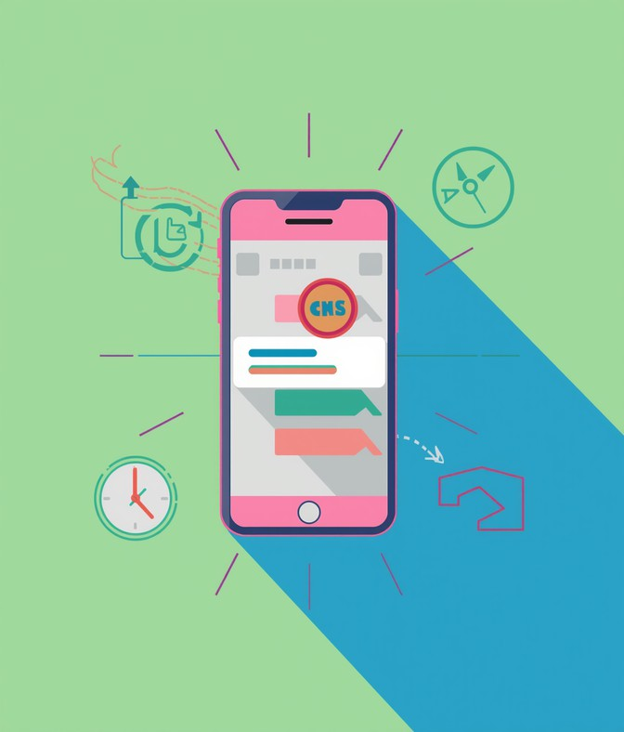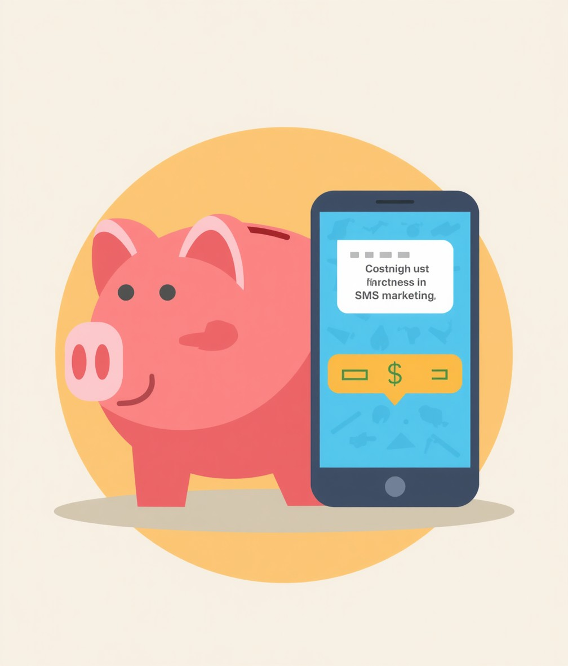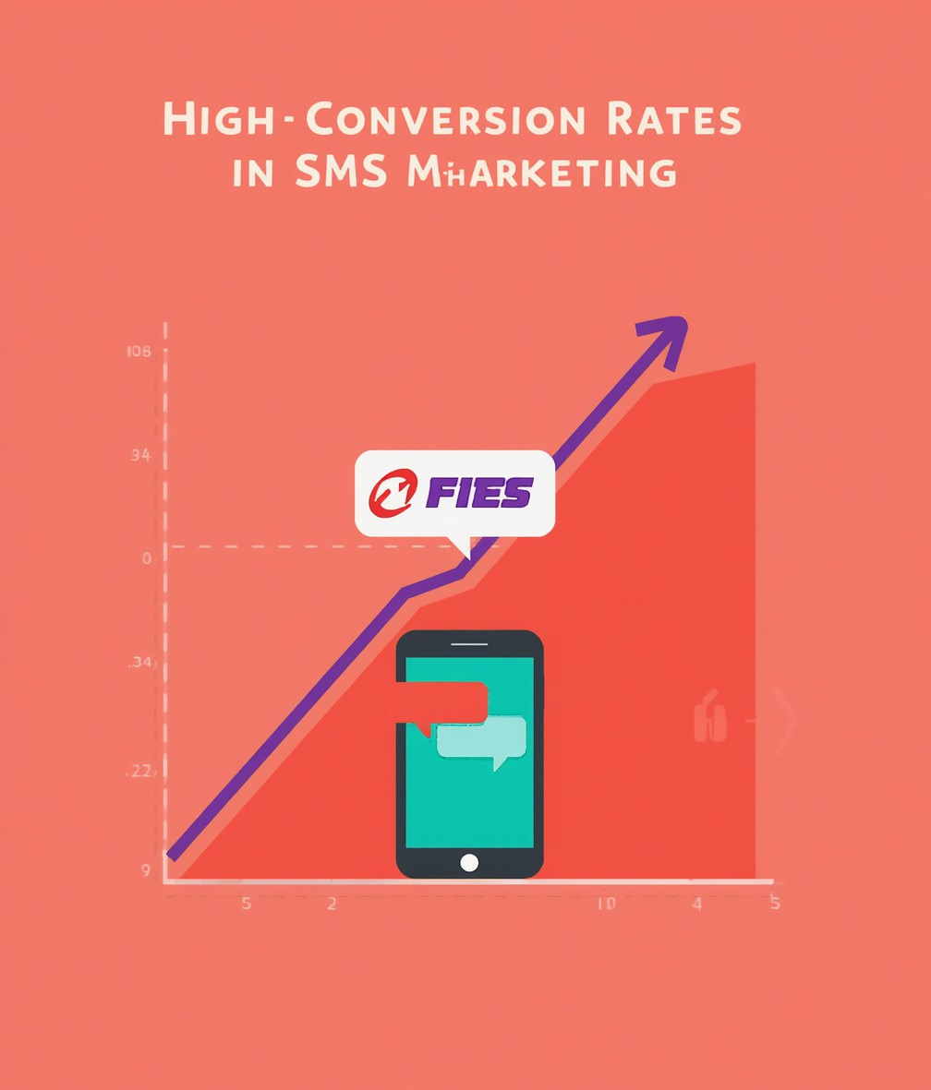

Best Practices for SMS Campaigns

Obtain Consent
Ensure customers opt-in before messaging.

Keep Concise
Deliver clear messages without unnecessary details.

Send Optimal Times
Respect customer preferences for sending messages.

Clear CTA
Include straightforward calls to action in messages.

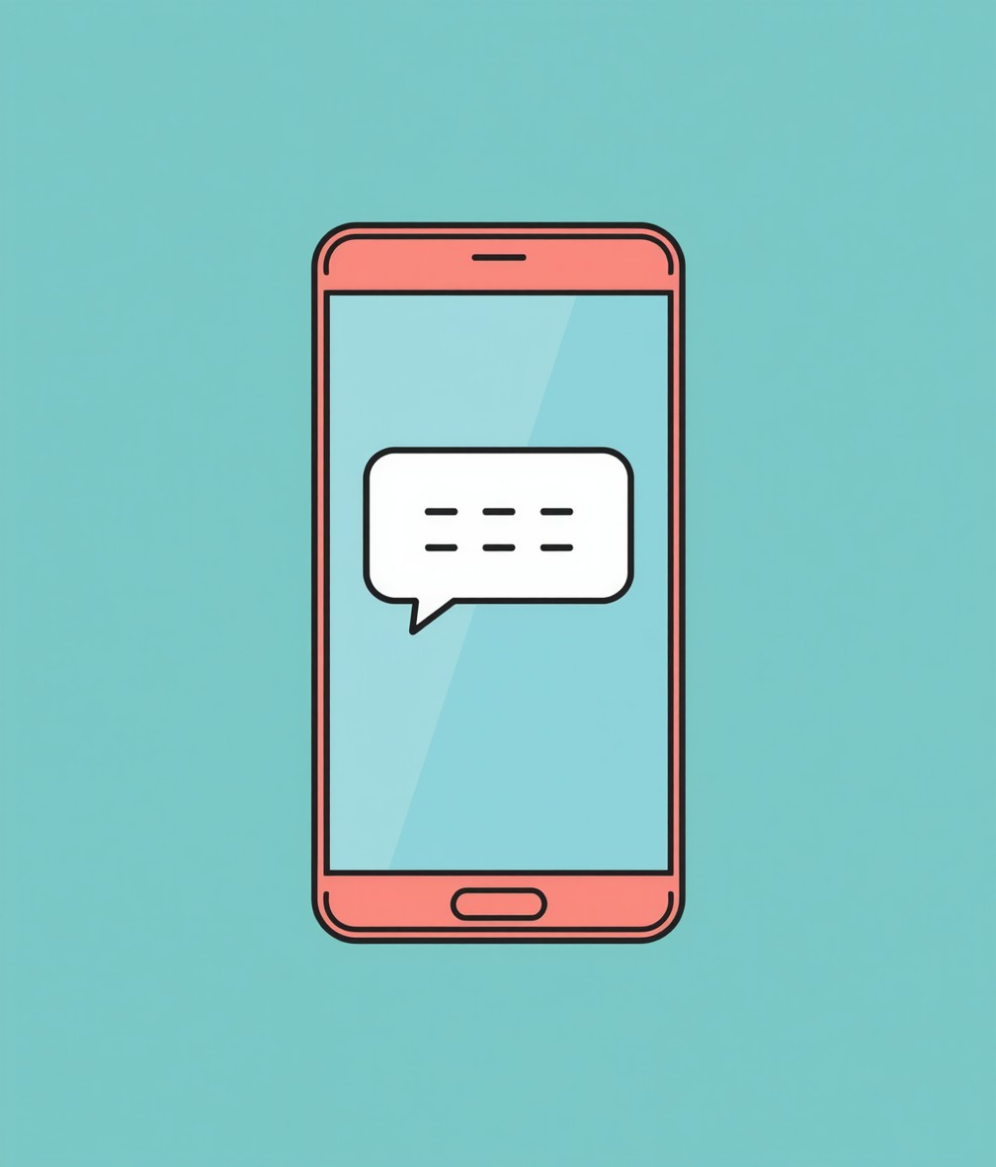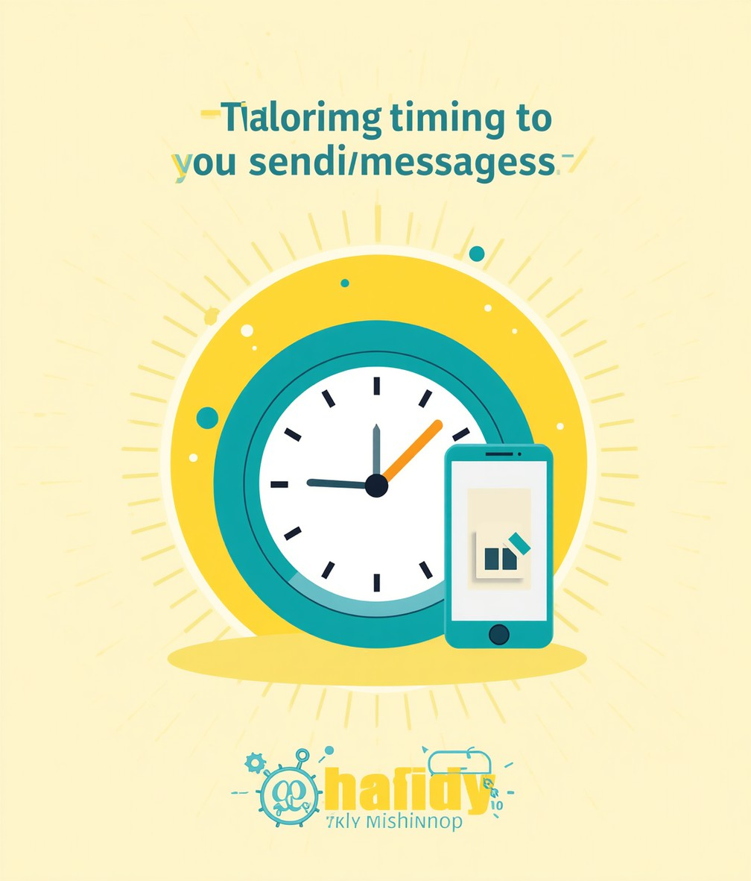

Compliance Regulations

Understanding Legal Requirements for SMS Marketing

Navigating the landscape of SMS marketing requires awareness of essential regulations, such as the TCPA and GDPR. These laws emphasize the
importance of obtaining explicit customer consent and maintaining data
privacy. Non-compliance can result in significant penalties, making it crucial for marketers to stay informed and implement best practices to safeguard customer information.

SMS vs. Email
Comparing Engagement and Effectiveness of Channels

High Open Rate

SMS boasts an incredible open rate of 98%, often within minutes of receipt. This immediacy ensures that messages are seen quickly, making it an effective tool for time-sensitive promotions and alerts. Unlike email, which can be overlooked or filtered into folders, SMS delivers direct engagement, keeping your brand top-of-mind for customers.

Rich Content

Email allows for more detailed communication, supporting longer messages and rich media content. Its format is ideal for elaborate promotions, newsletters, and customer engagement strategies that require storytelling. While emails may have lower open rates, their potential for in-depth interaction makes them indispensable for comprehensive marketing campaigns, complementing SMS efforts effectively.

Launch Your Campaign

2026

Define goals and audience

2027

Build opt-in subscriber list

2028

Craft messages and schedule sends

2029

Monitor results and optimize

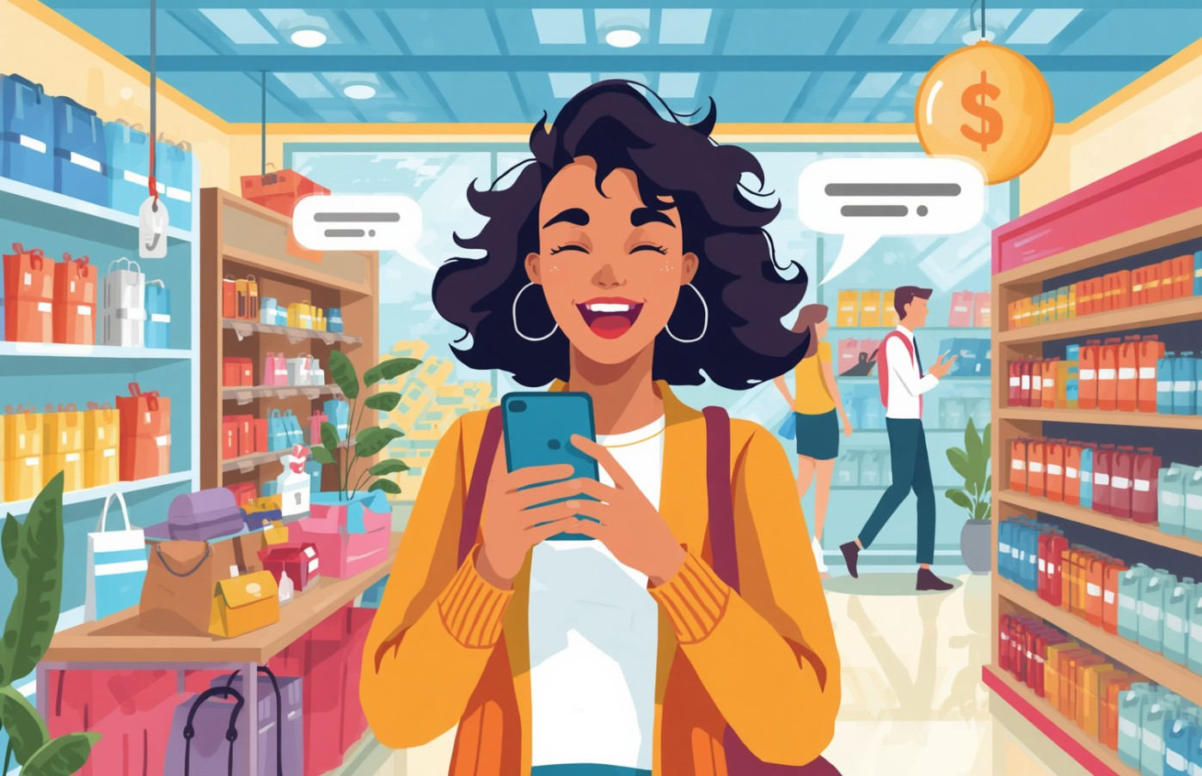

Case Study: Retail SMS Marketing Success

Customer Satisfaction
Increased sales and retention through targeted SMS campaigns.

Measuring SMS Campaign Effectiveness

Delivery Rate
Percentage of messages successfully delivered

Open Rate
Rate at which messages are opened

Click-Through Rate
Proportion of clicks on links within messages

Conversion Rate
Percentage of actions taken after engagement

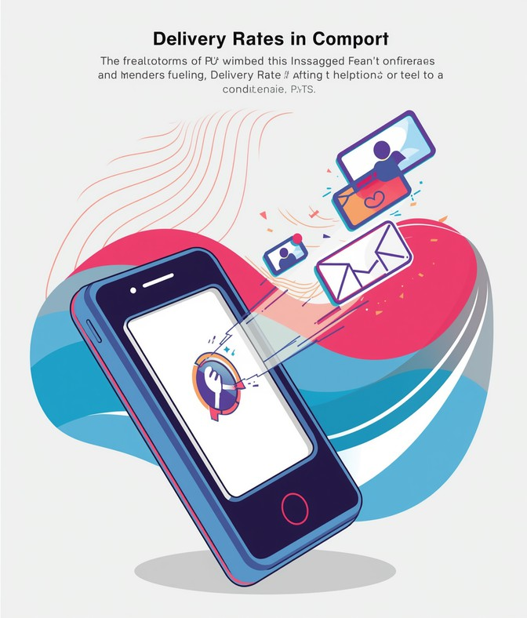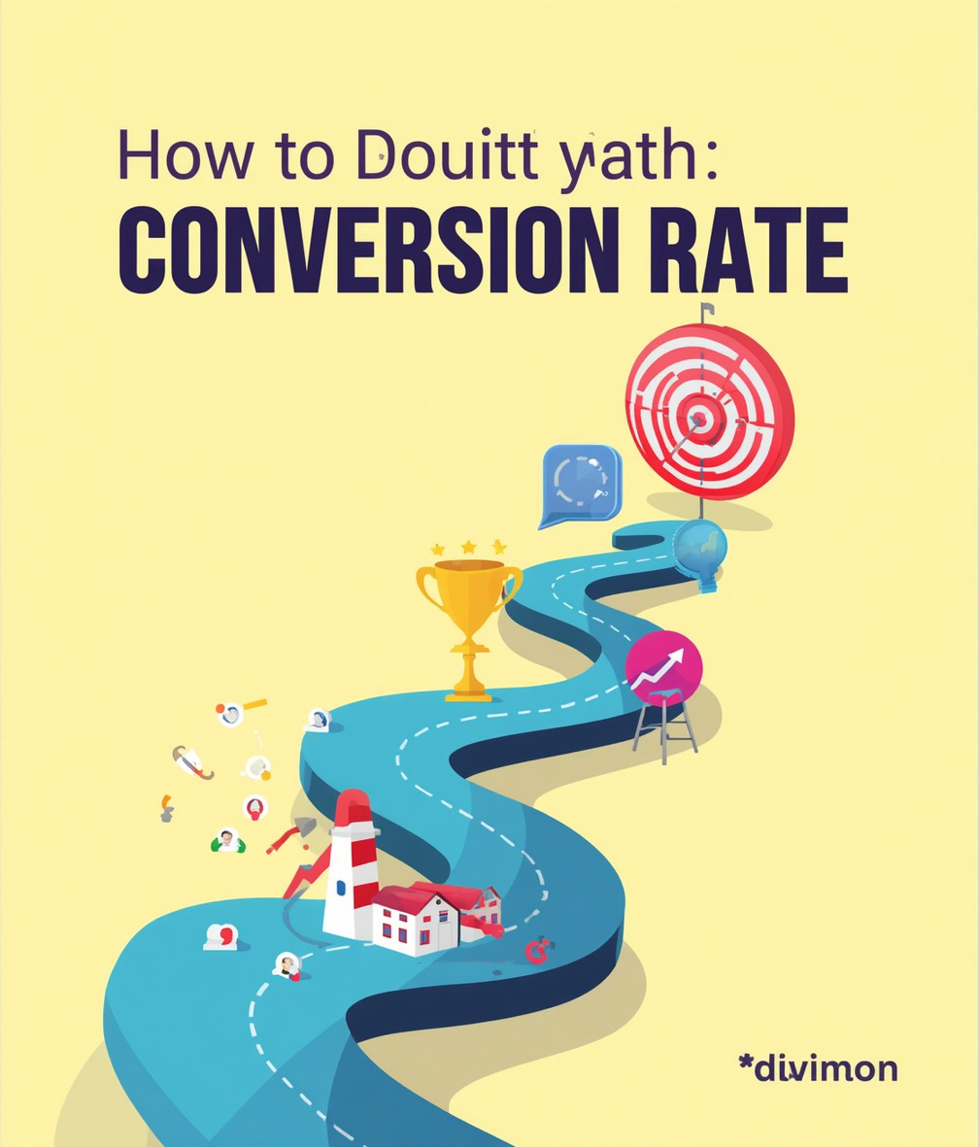

Next Steps to Enhance Strategy

Integrate SMS
Combine SMS with your existing channels

Personalize Messages
Tailor content based on customer data

Regularly Update
Keep subscriber lists and preferences fresh

A/B Testing
Experiment to find effective campaigns

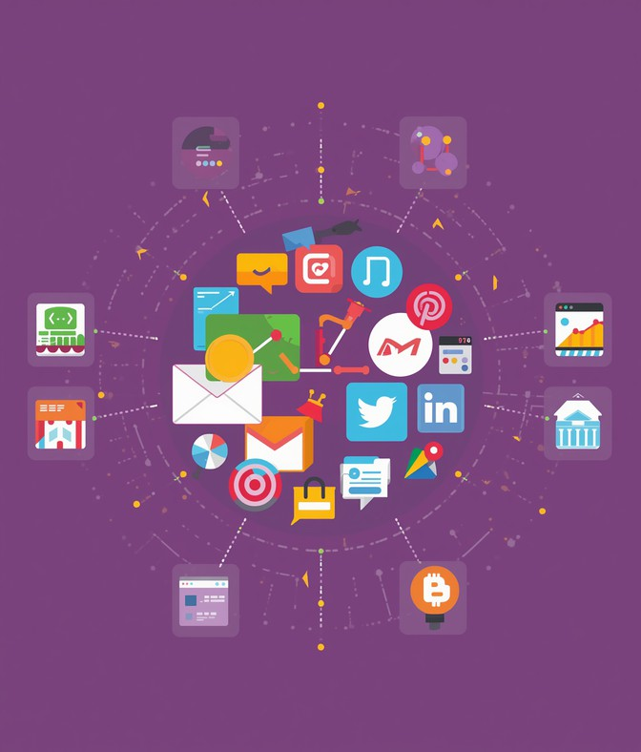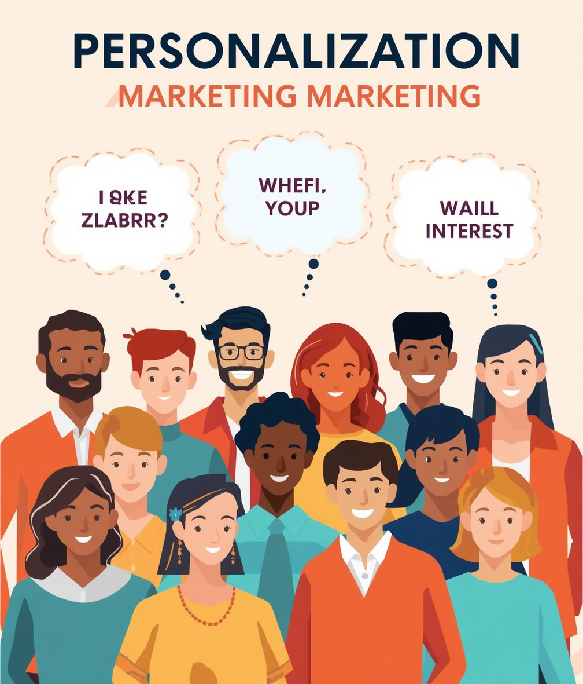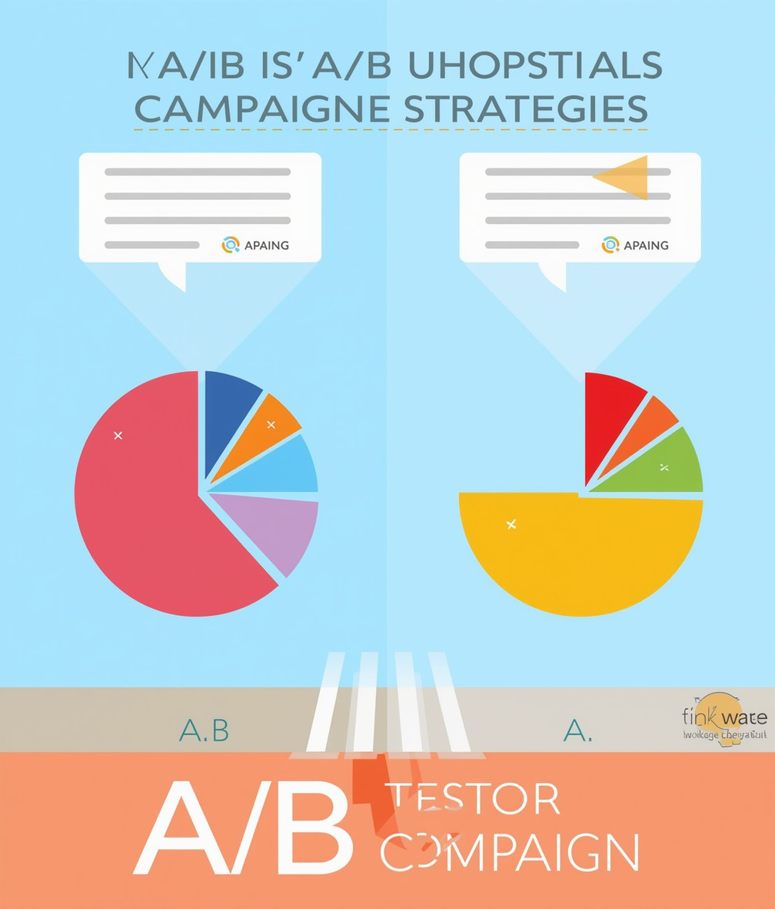

Thank You

Thank you for your attention! Any questions?
WEBSITE

smsdeals.co.in

EMAIL

sales@smsdeals.co.in

PHONE
+91-9810699052

