Tarpaulin Supplier in India: Why Businesses Trust Purav Tarpaulins for Monsoon Protection
When the monsoon hits, even a short leak can damage lakhs of rupees worth of raw material, machinery, or finished goods. That is why choosing the right tarpaulin supplier in India is not just a purchase decision, but a risk‑management decision for your business. Purav Tarpaulins has been helping industries protect their materials and project sites with reliable tarpaulin covers and monsoon sheds for decades, combining practical on‑site experience with durable products that actually perform in harsh weather.​
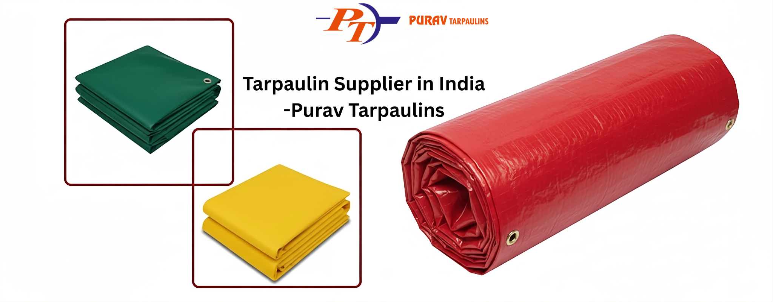

Who actually needs tarpaulins?
Tarpaulins are no longer used only for temporary shade or truck covers. Today, cement plants, steel yards, ports, warehouses, logistics hubs, and construction sites all depend on high‑quality tarpaulin solutions to keep materials dry and operations running smoothly during rain, dust, or shutdowns. If your business stores bulk material in open yards, operates outdoor loading zones, or sets up temporary structures, a dependable tarpaulin supplier in India becomes a long‑term partner, not just a vendor.​

Types of solutions Purav Tarpaulins offers
- Raw material covering solutions for cement, coal, clinker, and other bulk materials.
- Temporary monsoon sheds for factory premises, yards, and project sites.
- Pillar‑less dome‑type steel structure sheds for large, open spans.
- HDPE tarpaulins, silpaulin sheets, and packing materials for industrial use.

Benefits of choosing the right supplier
Better protection: Good quality tarpaulin resists tearing, UV damage, and water seepage, which directly reduces losses and rework.​
- Long‑term savings: A properly designed shed or cover system lasts multiple seasons, so you buy less frequently and avoid emergencies.
- Site‑specific design: An experienced supplier studies wind direction, load conditions, and movement paths before suggesting a solution, which Purav Tarpaulins can highlight as a key strength.

How to choose a tarpaulin supplier in India
- Experience and years in the industry.
- Range of products (HDPE, dome sheds, monsoon sheds, packing).
- Clients and sectors served (cement, steel, ports, infrastructure, chemicals).
- Ability to offer on‑site assessment and installation support.
- Responsiveness during monsoon or urgent shutdowns.

Why Purav Tarpaulins stands out
- Mention your years of experience and number of locations served.
- Talk about how your team actually visits sites, understands ground reality, and then suggests structures or coverings.
- Add a small story: e.g., how a client reduced material loss after switching to your monsoon sheds.
- Emphasize reliability, repeat orders, and long‑standing relationships with industrial customers.
If you are planning for the upcoming monsoon or facing recurring leakage and material damage, this is the right time to upgrade your protection plan. Instead of patchwork solutions, partner with a tarpaulin supplier in India that understands industrial pressures and tight timelines. Purav Tarpaulins can help you design, supply, and install complete tarpaulin and monsoon shed solutions tailored to your site.
You can:
- Visit: https://puravtarpaulins.in/
- Share your site photos, dimensions, and requirements for a quick suggestion.
- Schedule a call to discuss raw material covering, sheds, or custom tarpaulin needs.

