**Your guide to 30 must try e-liquids from Tidal Vape**

The search for the [perfect e-liquid flavour](https://tidalvape.co.uk/pages/e-liquid-flavours) never truly ends. With new options dropping constantly, it’s easy to overlook some seriously good e-liquids in favour of whatever’s trending.

Whether you’re switching from disposables or refreshing your current stash, this guide covers 30 carefully chosen vape liquids from Tidal Vape’s wide collection. Expect a mix of icy blends, fruity favourites, [classic tobacco](https://tidalvape.co.uk/collections/tobacco-e-liquid), and [menthol](https://tidalvape.co.uk/collections/menthol-e-liquid) bombs. All are available in nic salt or shortfill form, with something for every taste and routine.

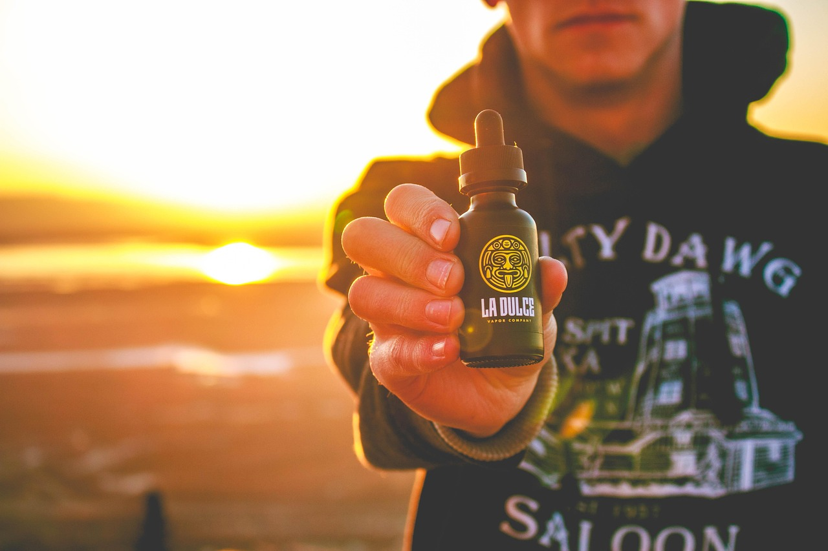

[**Crystal Clear Bar Range**](https://tidalvape.co.uk/collections/crystal-clear-bar-salts-nic-salt)

**1. Fizzy Cherry Nic Salt**

A fizzy cola-like cherry hit with smooth nic salt delivery.

* Great for fans of sweet-tart blends
* Ideal for all-day use

**2.** [**Blue Razz Lemonade Nic Salt**](https://tidalvape.co.uk/products/blue-razz-lemonade-nic-salt-by-crystal-clear-bar-salts)

Fruity blue raspberry meets a dash of lemonade fizz.

* Bright and tangy without overdoing it
* Refreshing, not icy

**3. Blueberry Sour Raspberry Nic Salt**

Deep blueberry richness with raspberry zing and sour finish.

* Well-balanced berry profile
* Smooth and full-bodied

**4. Strawberry Ice Nic Salt**

Simple sweet strawberries cooled with ice.

* Not over-mentholated
* Familiar and consistent

**5. Sour Apple Nic Salt**

Green apple sharpness with a crisp sour punch.

* Tart but gentle on the coil
* A bold palate cleanser

**6.** [**Lemon & Lime Nic Salt**](https://tidalvape.co.uk/products/lemon-lime-nic-salt-by-crystal-clear-bar-salts)

Two citrus classics combined in one refreshing vape.

* Clean and bright flavour
* Zero sugary residue

**7. Fresh Mint Nic Salt**

Straightforward cool mint without extras.

* Freshens your breath as well as your tastebuds
* Brilliant after meals

**8.** [**Mr Blue Nic Salt**](https://tidalvape.co.uk/products/mr-blue-nic-salt-by-crystal-clear-bar-salts)

A blue fruit medley with cooling edge.

* Dark berries with ice
* Smooth, reliable favourite

**9. Raspberry Watermelon Bubblegum Nic Salt**

Fruity with chewy bubblegum notes.

* Not overly sweet
* Layered flavour makes it interesting

**10. Pink Lemonade Nic Salt**

Zesty lemonade softened with berry undertones.

* Great for warm afternoons
* Light and citrusy

**11. Spearmint Gum Nic Salt**

Classic chewing gum taste with menthol

* Feels like a minty exhale
* Subtle and nostalgic

[**Vortex Range**](https://tidalvape.co.uk/collections/vortex)

**12. Pineapple Ice Nic Salt**

Tropical pineapple cooled down with a crisp finish.

* Not too icy
* Sweetness is gentle and realistic

**13. Sour Blue Raspberry Ice Nic Salt**

A bold blend of blue raspberry and chilled sour.

* Great for ex-disposable users
* Full of character

**14.** [**Apple Peach Ice Nic Salt**](https://tidalvape.co.uk/products/apple-peach-nic-salt-by-vortex-bar-series)

Juicy orchard apple and soft peach meet menthol.

* Sweet and cool without being heavy
* Balanced fruit layering

**15. Lemon & Lime Ice Nic Salt**

Icy citrus duo that clears the palate.

* Sharp and straightforward
* One for citrus lovers

**16. Menthol Ice Nic Salt**

High-impact cooling without any fruit.

* Good reset flavour between stronger vapes
* Works well as a mixer

**17.** [**Cherry Grape Ice Nic Salt**](https://tidalvape.co.uk/products/sour-cherry-grape-10ml-e-liquid-by-vortex)

Dark cherry and grape balanced with cool exhale.

* Smooth and juicy
* Long-lasting taste

**18. Watermelon Ice Nic Salt**

Sweet watermelon with clean menthol lift.

* Doesn’t taste artificial
* Easy-going and light

**19. Strawberry Lemonade Ice Nic Salt**

Bright strawberries and citrus with an icy twist.

* Great with drinks or outdoors
* Refreshing finish

**20. Blue Raspberry Ice Nic Salt**

Cool, bold blue raspberry with subtle menthol.

* Similar to popular disposable flavours
* Consistent and strong

**21. Mango Ice Nic Salt**

Ripe mango smoothed with a light chill.

* Tropical and soft
* Not overpowering

[**Vampire Vape Classics**](https://tidalvape.co.uk/collections/vampire-vape-e-liquid)

**22. Double Menthol E-Liquid**

Bold menthol blend for those who want extra chill.

* Clears the senses
* No added fruit or sweetness

**23.** [**Heisenberg E-Liquid**](https://tidalvape.co.uk/products/heisenberg-by-vampire-vape-eliquid)

Fruity aniseed with menthol kick.

* Complex and unforgettable
* A cult classic for a reason

**24.** [**Pinkman E-Liquid**](https://tidalvape.co.uk/products/pinkman-by-vampire-vape-e-liquid)

Mixed fruit explosion with citrus front.

* Light and tangy
* Great daily vape

**25. Blood Sukka E-Liquid**

Cherries, berries and menthol with a spicy twist.

* Slightly herbal
* Bold flavour profile

[**Doozy Vape Salts**](https://tidalvape.co.uk/collections/doozy-vape-e-liquids)

**26.** [**Tropical Tsunami Nic Salt**](https://tidalvape.co.uk/products/tropical-tsunami-by-vampire-vape-e-liquid)

Pineapple, passionfruit and mango rush.

* Exotic and juicy
* Good for summer

**27. Frozen Berries Nic Salt**

Dark forest berries chilled with menthol.

* Great balance between sweet and cool
* Not too candy-like

**28. Blue Raspberry Bubblegum Nic Salt**

Raspberry zing with chewy undertone.

* Feels nostalgic
* Very smooth

**29. Sweet Strawberry Nic Salt**

Sugary strawberry with a clean finish.

* Simple and safe choice
* Ideal for beginners

**30. Fizzy Orange Ice Nic Salt**

Orange soda vibes with cool citrus.

* Lively and fresh
* A surprising winner

**What you should know before buying**

If you're browsing for e-liquids and aren’t sure what to pick, here’s a little background to help you make an informed choice:

**VG/PG Ratio**

Most of the products listed above use a [50/50 VG/PG](https://tidalvape.co.uk/collections/vape-50-50-e-liquids) ratio. Here's what that means:

* VG (Vegetable Glycerin): Thicker liquid that produces more vapour and a smoother throat hit.
* PG (Propylene Glycol): Thinner and carries flavour better but gives more throat hit.

A 50/50 blend is ideal for beginner-friendly devices like pod kits or MTL (mouth-to-lung) tanks. It gives you a satisfying inhale and good flavour without needing a high-wattage device.

**Nicotine Type**

You’ll usually find two kinds:

* Nicotine Salts: Smoother and more stable. Great for heavy smokers switching over.
* Freebase Nicotine: Hits harder and feels more like traditional cigarettes.

All the Crystal Clear, Vortex, Doozy, and Vampire options listed are available in nicotine salt versions.

**Why buy from Tidal Vape?**

* Trusted brands only: All products are TPD compliant
* Frequent deals: 4 for £10 offers make it affordable to try more
* UK-based support: Friendly team if you have questions
* Free delivery options: Fast dispatch and flexible shipping
* Retail + online: Easily find your favourites in-store or at home

Whether you’re upgrading your current stash or trying vaping for the first time, Tidal Vape keeps it simple, reliable and accessible.

**Final Word**  
This list is a great place to start or mix up your rotation. Whether you’re drawn to classics like Heisenberg, fruity blends like Apple Peach Ice, or wildcards like Fizzy Orange Ice, every bottle here has earned its spot through popularity, performance and balance.

Try a few and see what sticks because the best vape is the one you keep coming back to.